**Tutorial 29: Two-way Data Binding – Select Fields**

We can use v-model with other form fields other than input boxes. We will be focusing on the select input field in this tutorial.

Make sure **Tutorial 28** is complete to be able to move on to this tutorial or clone the [vue3-firebase-course](https://github.com/younggrasshopperza/vue3-firebase-course) repository and go to branch called **Tutorial-28** and navigate to the web-form folder.

**Step 1:** In the **Signup.vue** file, we will be creating a user role that will have a dropdown option. Inside the form tag under the password input, create a label tag with the name role. Create a select tag, inside the select tag, create a series of option tags, include value attribute for each user role.

Look at the example below (**Between line 9 and 15**):

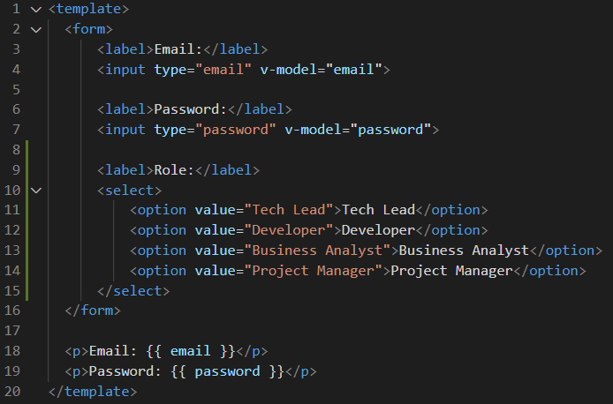

**Output:**

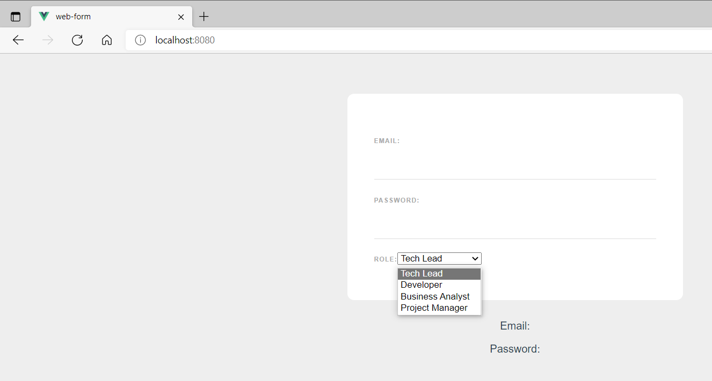

**Step 2:** In the **Signup.vue** file, create a data property called role. Include the v-model attribute to the select tag with the value role. The value of the option will be assigned to the data property. Create a paragraph tag under the paragraph outputting the password and output the role data property.

Look at the example below (**Line 10 and line 28**):

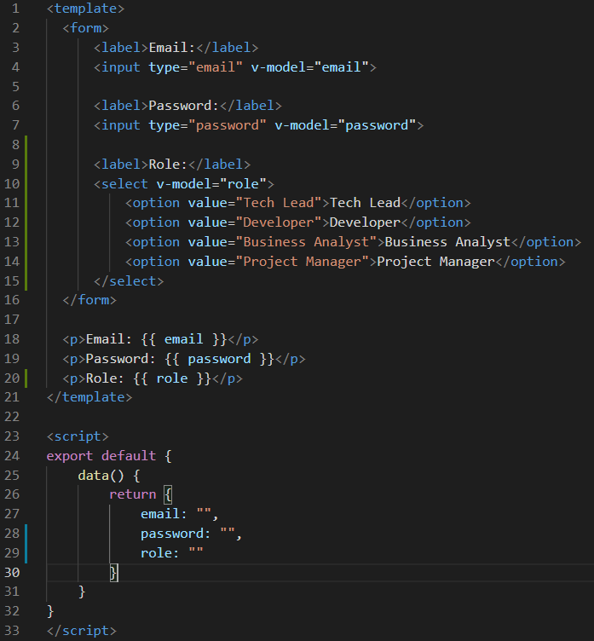

**Output:**

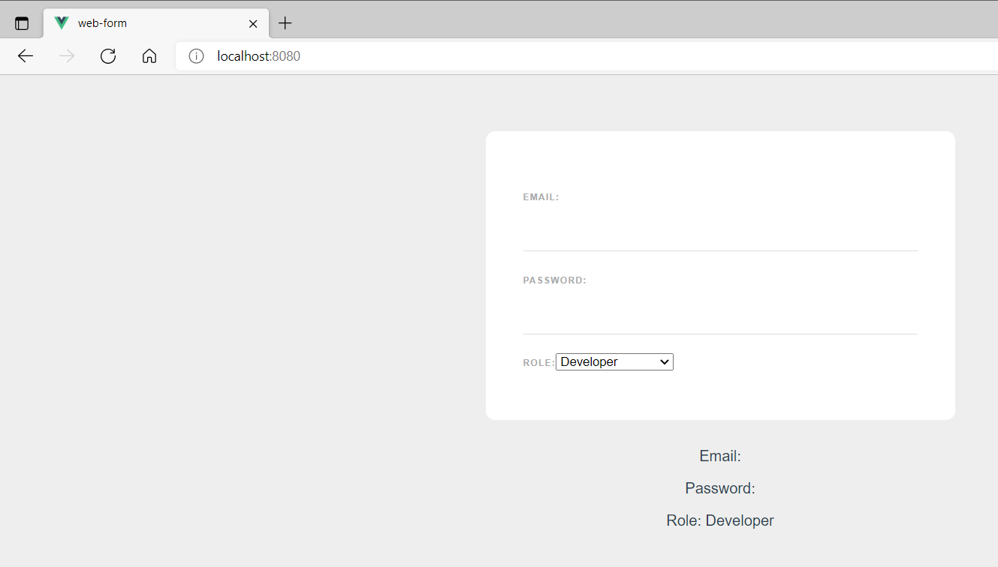

By default, we will not see an option. If we want a default option, we need to type out the value in the data property for the role.

**Line 29 example:**

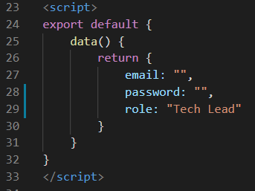

**Output:**

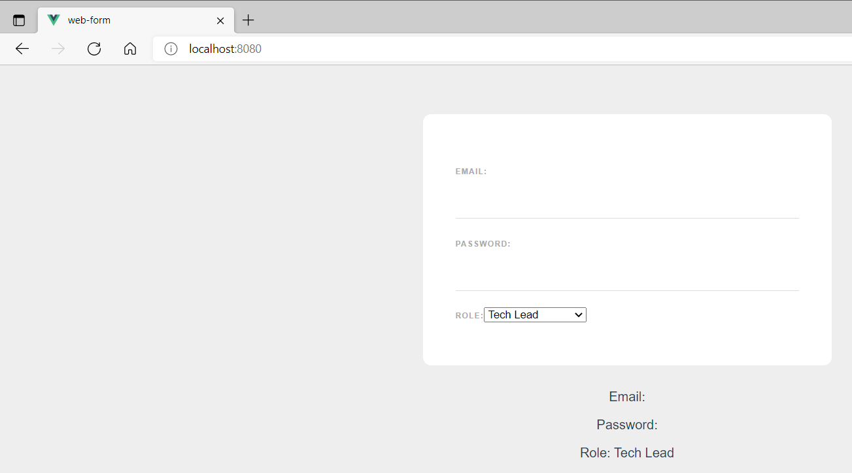

**Step 3:** In the **Signup.vue** file, edit the style for the select by adding select next to the input in the css.

Look at the example below (**Line 53**):

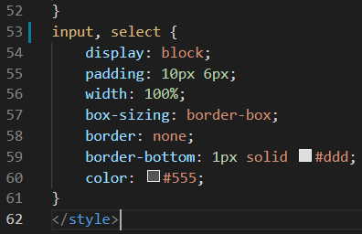

**Output:**

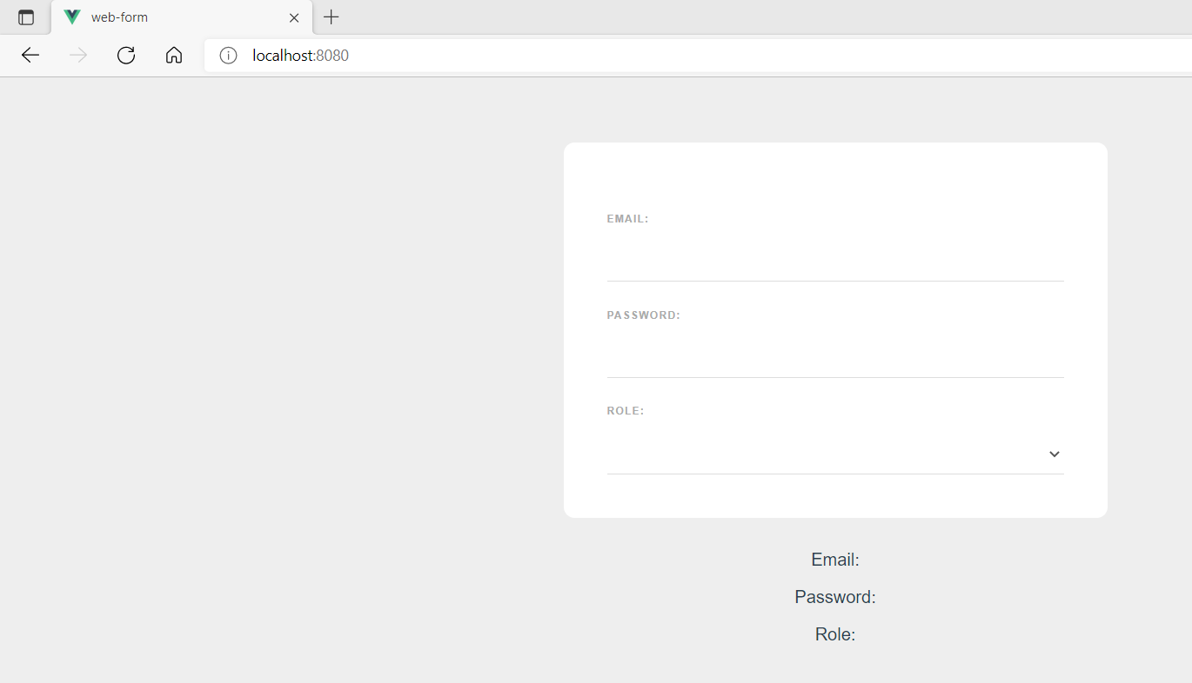

**You can view the code snippets from the** [**vue3-firebase-course**](https://github.com/younggrasshopperza/vue3-firebase-course) **repository under the Tutorial-29 branch**.